**Intruder Detection System**



A Project report submitted in partial fulfillment of requirements for the award of degree of

**BACHELOR OF TECHNOLOGY**

**IN**

**COMPUTER SCIENCE AND BUSINESS SYSTEMS**

**by**

**P.VINAY (219X1A2956)**

**SHAIK SADDAM HUSSAIN (229X5A2973)**

**KONDURU YASHWANTH (219X1A2949)**

**Under the esteemed guidance of**

**Sri. K.SREEDHAR BOYA**

**Assistant Professor**

**Department of ECS.**

**Department of Emerging Technologies in Computer Science**

**G. PULLA REDDY ENGINEERING COLLEGE (Autonomous): KURNOOL**

**(Affiliated to JNTUA, ANANTAPUR)**

**2024– 2025**

**Department of**

**Emerging Technologies in Computer Science**

**G. PULLA REDDY ENGINEERING COLLEGE (Autonomous): KURNOOL**

**(Affiliated to JNTUA, ANANTAPUR)**



**CERTIFICATE**

***This is to certify that the Project Work entitled*** ‘INTRUDER DETECTION SYSTEM ’ **is a bonafide record of work carried out by**

**P.VINAY (219X1A2956)**

**SHAIK SADDAM HUSSAIN (229X5A2973)**

**KONDURU YASHWANTH (219X1A2949)**

Under my guidance and supervision in partial fulfillment of the requirements for the award of degree of

**BACHELOR OF TECHNOLOGY**

**IN**

**COMPUTER SCIENCE AND BUSINES SYSTEMS**

|  |  |  |  |
| --- | --- | --- | --- |
| **Sri. K.SREEDHAR BOYA** Assistant Professor,  Department of ECS.,  G. Pulla Reddy Engineering College,  Kurnool. | | **Dr. R. Praveen Sam**  Professor & Head of the Department,  Department of ECS.,  G.Pulla Reddy Engineering College,  Kurnool. | |
| **Signature of the External Examiner** | **: ……………………………..** | |

**DECLARATION**

We hereby declare that the project titled “**Intruder Detection System**” is an authentic work carried out by me as the student of **G. PULLA REDDY ENGINEERING COLLEGE (Autonomous) Kurnool**, during 2024-25 and has not been submitted elsewhere for the award of any degree or diploma in part or in full to any institute.

**P.Vinay**

**(219X1A2956)**

**Shaik Saddam Hussain**

**(229X5A2973)**

**Konduru Yashwanth**

**(219X1A2949)**

# ACKNOWLEDGEMENT

We wish to express our deep sense of gratitude to our project guide **Sri. K.SREEDHAR BOYA**, **ASSISTANT PROFESSOR** of Emerging Technologies in Computer Science Department, G. Pulla Reddy Engineering College, for her immaculate guidance, constant encouragement and cooperation which have made possible to bring out this project work.

We are grateful to our project in charge **Sri. VINAY KUMAR**, **ASSISTANT PROFESSOR** of Emerging Technologies in Computer Science Department, G. Pulla Reddy Engineering College, for helping us and giving us the required information needed for our project work.

We are thankful to our Head of the Department **Dr. R. PRAVEEN SAM**, for his whole hearted support and encouragement during the project sessions.

We are grateful to our respected Principal **Dr.B.SREENIVAS REDDY** for providing requisite facilities and helping us in providing such a good environment.

We wish to convey our acknowledgements to all the staff members of the Emerging Technologies in Computer Science department for giving the required information needed for our project work.

Finally, we wish to thank all our friends and well wishers who have helped us directly or indirectly during the course of this project work.

# ABSTRACT

The Theft Detection System using Video Surveillance is an innovative application of computer vision and artificial intelligence technologies aimed at enhancing security in various public and private spaces.

The system utilizes video cameras strategically placed in target areas to monitor and detect potential theft incidents is real time. With the increasing demand for advanced security measures, this system provides a robust solution to prevent theft and protect assets effectively.

The core functionality of the Theft Detection System relies on cutting-edge deep learning algorithms and computer vision techniques. The video streams captured by the surveillance cameras are processed in real-time to identify suspicious activities and detect theft-related behaviors.

The system can recognize a wide range of objects and actions, including unauthorized item removal, shoplifting, and other forms of theft. The Theft Detection System using Video Surveillance presents a powerful solution to counter theft and improve security in various environments.

By leveraging cutting-edge computer vision and artificial intelligence technologies, the system can promptly detect and mitigate potential theft incidents, thus reducing losses and enhancing overall safety. Its versatility and scalability make it a valuable addition to any security infrastructure, offering peace of mind to businesses and public spaces alike**.**

# CONTENTS

**Page No**

## INTRODUCTION

* 1. Introduction
  2. Motivation
  3. Problem Definition
  4. Objective of the Project
  5. Limitations of the Project
  6. Organization of the Report

## SYSTEM SPECIFICATIONS

* 1. Software Specifications
  2. Hardware Specifications

## LITERATURE SURVEY

* 1. Introduction
  2. Existing System
  3. Disadvantages of Existing System
  4. Proposed System

## DESIGN AND IMPLEMENTATION

* 1. UML Diagrams
  2. Module Description
  3. Why YOLOv5 Model?
  4. Code Implementation

## RESULTS

1. **CONCLUSION AND FUTURE ENHANCEMENT**
2. **INTRODUCTION**

## Introduction

In today's world, keeping people and places safe is crucial. This project aims to create a smart security system using advanced technologies to detect objects and recognize faces.

This project uses a powerful tool called YOLOv5 to watch a live video from a webcam and quickly identify and track people. Another tool, face recognition, helps system to recognize familiar faces from strangers.

One standout feature of this system is its ability to send alerts. If someone unfamiliar is detected, this system takes a picture and sends an email alert to a higher officials. This allows for quick responses to potential security issues.

To make the system even more reliable, system also checks incoming emails for specific information, adding an extra layer of confirmation about a person's identity. This project also includes audible alarms to the mix. These are sounds that can be heard, alerting people to the presence of someone unfamiliar or other important security events.

Designed with simplicity in mind, this project is perfect for smaller security setups. This system continuously monitor, send alerts in real-time, and keep a record of images with timestamps, providing a comprehensive security solution for everyday use.

As going through this report, we'll dive into more details about how the system works, what it can do, how it's built, and how well it performs. This will help us understand why this integrated security system is important and how it could be useful in different situations.

# Motivation

The reason for doing this project is because many people need an easy and good way to keep their places safe. We want to make a security system that's not hard to use but still works well. With new technology, we can make something that quickly spots things and recognizes faces.

Other security systems can be slow or not very smart in noticing possible problems. Our goal is to change that. We want to give everyone a tool that makes their spaces safer without being complicated. By using technology like YOLOv5 and face recognition, we can make our security system strong and quick.

Our main aim is to offer people something that works well and is simple to use. We combined watching things in real-time, recognizing faces, and sending quick alerts to create a complete solution. We think everyone should have access to good security that doesn't need a tech expert.

Nowadays, many homes are becoming smart, and we believe security should be smart too. Our project wants to bring the benefits of modern technology to security in a way that's helpful and easy for everyone.

In the end, our hope is to help make living and working spaces safer and more comfortable. We trust this project can be a step towards giving people more peace of mind about their security.

## Problem Definition

The motivation behind this project arises from the challenges observed in conventional security systems, particularly in their responsiveness and adaptability to emerging security threats.

Traditional surveillance methods often lack real-time capabilities and struggle to provide effective responses to potential risks. This creates a need for a security system that can seamlessly integrate advanced technologies to overcome these limitations.

### Key Challenges:

1. **Limited Responsiveness:** Traditional security systems may not respond quickly to potential security threats, leading to delayed or inadequate actions in critical situations.
2. **Complexity in Implementation:** Many existing security solutions are complex to set up and use, requires technical expertise.
3. **Ineffective Verification:** The absence of robust verification mechanisms may result in false alarms or uncertainty regarding the identity of individuals within a monitored space.
4. **Limited Accessibility:** The accessibility of advanced security features to a broader audience, including those in smart home environments, may be restricted due to complexity and high costs. By addressing these challenges, the project aims to develop an integrated security system that combines object detection, face recognition, and efficient alerting mechanisms. The goal is to create a solution that is responsive, user-friendly, and accessible to individuals seeking to enhance the security of their living or working spaces.

**1.4 Objective of the Project**

The objective of this project is to develop an efficient **Intruder Detection System** using **video surveillance** and **computer vision** techniques. The system aims to enhance security by detecting unauthorized individuals in a monitored area and triggering real-time alerts. Key goals include:

* **Real-Time Intrusion Detection**: Using **YOLOv5 for object detection** and **face recognition** to identify intruders.
* **Automated Alerts**: Sending email notifications with attached intruder images for security personnel.
* **Alarm Activation**: Triggering an alarm when an intruder is detected to deter unauthorized access.
* **Optimized Face Location Checking**: Enhancing recognition accuracy and reducing false positives.
* **User Interface Integration**: Developing a frontend to display detections and allow user interaction.

**1.5 Limitations of the Project**

While the system offers significant security advantages, it has some limitations:

* **Lighting Conditions**: Poor lighting can reduce face recognition accuracy and object detection performance.
* **False Positives & Negatives**: The system may misidentify authorized individuals as intruders or fail to detect actual threats.
* **Processing Power Requirement**: Running **YOLOv5** and real-time surveillance requires high computational resources.
* **Network Dependency**: Email notifications and remote access features rely on stable internet connectivity.
* **Scalability Challenges**: Large-scale deployments may require additional hardware optimization for real-time processing.

**1.6 Organization of the Report**

This report is structured as follows:

* **Introduction**: Overview of the project, motivation, and significance.
* **Literature Review**: Summary of existing security systems, related research, and technologies used.
* **System Architecture**: Detailed explanation of the components, including hardware, software, and algorithms.
* **Implementation Details**: Technical aspects of the project, including YOLOv5 integration, face recognition, and alert mechanisms.
* **Testing and Evaluation**: Performance analysis, accuracy testing, and improvements made.
* **Limitations and Future Scope**: Discussion of existing challenges and potential enhancements.
* **Conclusion**: Summary of findings and overall project impact.

1. **SYSTEM SPECIFICATIONS**

## Software Specifications

### Object Detection:

* + Utilize YOLOv5 model for object detection.
  + Minimum accuracy threshold for object detection: 90%.

### Face Recognition:

* + Implement face recognition using the face recognition library.
  + Recognize known faces with a minimum accuracy threshold of 95%.

### Email Integration:

* + Integrate email functionality to send alerts.
  + Use SMTP for email sending.
  + Support for email attachment with detected intruder images.

### Email Verification:

* + Implement IMAP functionality to check incoming emails.
  + Verify the subject of received emails for additional confirmation.

### Audible Alarms:

* + Use Pygame library for playing audible alerts.
  + Differentiate between intruder alerts and verification alerts in different sounds.

### Continuous Monitoring:

* + Establish a real-time video feed from the webcam.
  + Implement a loop for continuous monitoring.
  + Store images in a specified folder for future reference.

### Time stamped Image Logging:

* + Save detected intruder images with time stamped filenames.

### User Interface (UI):

* + Display video feed with bounding boxes around detected objects
  + Provide a simple and clear interface for user interaction.

### Security and Privacy:

* + Implement secure email communication using SSL/TLS for SMTP.
  + Ensure the system adheres to privacy standards and regulations.

### Compatibility:

* + Ensure compatibility with a variety of webcams and environments.
  + Design the system to work seamlessly on different operating systems.

### Scalability:

* + Design the system to accommodate future updates or additional features.
  + Ensure scalability for integration with other smart home devices.

### Documentation:

* + Develop comprehensive documentation for installation, configuration, and usage.

Include a troubleshooting guide for common issues. These software specifications outline the key features and requirements of the project, ensuring a reliable, user-friendly, and secure security system.

## Hardware Specifications:

### Webcam:

* + Minimum webcam resolution: 720p HD.
  + USB interface for easy connectivity.

### Processing Unit:

* + Minimum processor requirement: Dual-core, 2.0 GHz or equivalent.
  + Adequate processing power to handle real-time video feed and object detection.

### Memory (RAM):

* + Minimum RAM requirement: 4 GB.
  + Sufficient memory for smooth operation, especially during video processing

### Storage:

* + Minimum storage space: 20 GB.
  + Adequate storage for saving time stamped images and system-related files.

### Graphics Processing Unit (GPU):

* + Recommended GPU for improved performance in video processing.
  + Optional, but beneficial for faster object detection

### Speakers:

* + Standard audio output for playing audible alarms.
  + Compatibility with built-in or external speakers.

### Internet:

* + Ethernet or Wi-Fi connectivity for email communication.
  + Stable internet connection for email alerts and verification.
  + Compatibility with various monitor types and sizes.

### User Interface (UI):

* + Display Monitor: Minimum 720p resolution.

### Operating System:

* + Compatibility with Windows, Linux, and mac OS.
  + Ensure the system functions seamlessly across different operating systems.

### USB Ports:

* + Sufficient USB ports for connecting the webcam and other peripherals.
  + Ensure compatibility with USB 3.0 for faster data transfer.

### Power Supply:

* + Adequate power supply for continuous operation.
  + Compatibility with standard power outlets.

### Lighting:

* + Room should consist of adequate lighting.

These hardware specifications outline the minimum requirements and recommendations for the proper functioning of the security system. Adherence to these specifications ensures optimal performance and a seamless user experience.

# LITERATURE SURVEY

## Introduction

1. Bank is using video cameras for the purpose of surveillance at many branches, ATM's and digital lobbies. Getting video analytics of different parameters from the video recording will help the bank to resolve many operational issues at the branches. The bank desires to explore video analytics for understand the customer sentiments, recognize the patterns /behaviors/movements in sure branches for proactive surveillance and provide better offerings to customers. The system can be utilized by banks, department shops, restaurants, schools, etc. The web based gadget takes video enter at a sure frequency and analyzes primarily based upon deep mastering algorithms and is expected to enhance the specificity and efficiency of information furnished at the portal. The average accuracy of the whole system is about 60–70 percentage including individual working and result of all algorithms.
2. In recent times, we have seen a massive rise in vision-based applications, such as video anomaly detection, motion detection, object tracking, people counting, etc. Most of these tasks are well defined, with a clear idea of the goal, along with proper datasets and evaluation procedures. However, perimeter intrusion detection (PID), which is one of the major tasks in visual surveillance, still needs to be formally defined. A perimeter intrusion detection system (PIDS) aims to detect the presence of an unauthorized object in a protected outdoor site during a certain time. Existing works vaguely define a PIDS, and this has a direct impact on the evaluation of methods. In this paper, we mathematically define it. We review the existing methods, datasets and evaluation protocols based on this definition. Furthermore, we provide a suitable evaluation protocol for real-life application. Finally, we evaluate the existing systems on available datasets using different evaluation schemes and metrics.
3. The system aims to give CCTV cameras the ability to detect suspicious activity, without human intervention. The goal of this paper is to identify suspicious activity for Surveillance and alert the shop owners when suspicious activity is detected. Electronic Article Surveillance (EAS) systems are widely used in today's retail stores, but this system is not capable enough as the shoplifters can easily remove the tag or label from the product. Hence, this system aims to take real-time videos from CCTV as an input and pass it to the CNN model created with the help of transfer learning and detect `Shoplifting', `Robbery' or `Break-In' in the store and notify it to the owners as soon as it occurs. Finally the main motive is to provide a system that detects suspicious activities without human intervention and generates alert, thus making a huge revolution in today's surveillance system.
4. Intrusion of terrorists and trespassers are adversely affecting the peace and harmony in the nation. The fatalities and disturbances caused by the latest Uri attack in Indian Army Camp show the necessity of an efficient border surveillance and intruder detection system for the effective monitoring and detecting the unauthorized movement of intruders across the national borders. Conventional border patrolling lacks an integrated multi-sensing system that coordinates various technologies for surveillance and detection of human intruder movement in the different border scenarios: flat surface movement, river/pond crossing and dry leaves movement. This paper describes the current Wireless Sensor Network (WSN) techniques related to intruder detection and border surveillance. Our future work focuses on delivering an improved multi-sensing system for detecting intrusion activities to secure the national borders.
5. Ad hoc networks have been serving us in one way or the other, for two decades, through their vast variety of applications in majority fields. Due to their features such as hostile deployments, high level of mobility, limited resources and physical insecurity, they are in front line to attackers. First line of defense (cryptographic techniques, fire walls etc.) stops these attacks. But what would happen if the attacker breaks through this defense system? Second of line of defense also called intrusion detection system (IDS), would stop and mitigate these threats before they harm the network or its resources. Various schemes have been proposed to provide quality IDS that could mitigate the latest threats in ad hoc networks. In this review paper, we gave a detailed overview of ad hoc networks in the start. We explored ad hoc networks security followed by description about IDS. Next, we elaborated the taxonomy of IDS, containing types of IDS based on numerous parameters. In the trailing section, we compared wide variety of IDS schemes based on different methodology/techniques, to show their importance and performance in the field of intrusion detection. Finally, we concluded the paper with informative future research directions in the state of the art research fields that would open up ways for researchers in that area.
6. The phrase "identification" refers to a person's uniqueness. Despite the fact that anomalies are typically local, occurring in a specific area of the frame, no previous research has looked into the role of locality. This system aims to detect real-world irregularities in surveillance videos on college campuses, such as burglary and assaults. The number of recorded criminal events each day is rapidly growing in several countries. The need for an efficient method of intruder detection, as well as crime investigation and the identification of deceased bodies, has arisen. One part of criminal identification and dead body identification is image processing using machine learning techniques. In this work, we explore the impact of considering spatiotemporal tubes instead of whole-frame video segments. For this purpose, we enrich existing surveillance videos with spatial and temporal annotations: it is the first dataset for criminal identification and crime scene detection with bounding box supervision in both its train and test set. Our tests show that a network trained with spatiotemporal tubes outperforms an equivalent model trained with whole-frame videos. By doing so, we can grow our spatiotemporal crime scene dataset without the need for additional human classification.
7. This system provides an automated video surveillance and alarm system to alert the security guard via his cell phone of any undesired activity caught on the surveillance cameras. Once any suspect intrusion is detected, the surveillance camera will capture the frame with the intrusion and send to the handheld device of the people related. The scope of the research covers mainly the aspects of digital image processing relevant to differentiate between two images quickly and accurately and the automation of message sending, be it email, SMS or MMS, with no human interaction. Demonstrated by the experimental result, it is a promising replacement of traditional human video surveillance monitor system.
8. As the principal place for currency flow nowadays, the banking system plays a special role in society and its security has always been a focus. The current bank branches' security systems usually use video surveillance system, which is basically used to provide evidence after incidents, and it cannot do real-time warning. With the rapid development of computer vision, video and intelligent recognition, real-time alarm analysis of surveillance system has become possible. Based on the technologies of human body detection, motion tracking and behavior judgment, this article designs a bank intelligent video image processing and monitoring control system which is based on Open CV, and the system not only realizes real-time monitoring and alarm within monitoring zone effectively, but also brings innovations to the traditional video surveillance system, providing strong protection of safe operation for banks.

In conclusion, the integration of YOLOv5 in intruder detection using video surveillance, coupled with alarm generation and email notifications, represents a significant leap forward in the field of security systems. The combination of real-time, accurate object detection, immediate alarm response, and seamless communication through email notifications creates a comprehensive and proactive security solution. This technology not only deters potential intruders but also provides a rapid, informed, and coordinated response to security breaches, ultimately fostering safer environments for individuals, businesses, and communities.

## Existing System

In recent years, the rapid evolution of technology has brought about sophisticated intruder detection systems using video surveillance, playing a vital role in enhancing security across residential, commercial, and public spaces. This analysis delves into various existing intruder detection systems, shedding light on their features, advantages, and limitations.

1. Traditional Motion Detection Systems:

Traditional systems, reliant on pixel value changes in video frames, are costeffective but prone to high false alarm rates due to factors like lighting changes. Differentiating between intruders and other moving objects remains a challenge.

1. Infrared-Based Intruder Detection:

Infrared systems, using heat signatures to detect living beings, prove effective in low-light conditions but may trigger false alarms from non-human heat sources. Their application is limited due to range constraints.

1. Acoustic Intruder Detection Systems:

Acoustic systems, employing microphones to capture sounds associated with intruders, offer additional information but are susceptible to ambient noise. Lack of visual confirmation makes accurate identification challenging.

1. Video Analytics-Based Intruder Detection:

Video analytics systems, powered by machine learning algorithms, analytics behavior, size, and movement patterns. While advanced, they require significant computational power and accuracy hinges on training data quality.

1. Machine Learning and Deep Learning-Based Intruder Detection:

ML and DL techniques, especially using CNNs, significantly enhance accuracy by extracting complex features from video frames. Their adaptability to different environments and continuous improvement make them promising for modern surveillance.

1. Behavior Analysis and Pattern Recognition:

Advancements in behavior analysis and pattern recognition involve studying movement patterns for identifying deviations as potential intruders. This nuanced approach reduces false alarms and boosts system reliability.

1. Integration with IoT Devices:

Integrating intruder detection with IoT devices expands surveillance capabilities. Smart sensors and cameras collaborate to provide real-time data, enabling automated responses like lighting activation or security alerts.

Intruder detection systems have evolved from basic motion detection to sophisticated video analytics, offering higher accuracy. However, these advancements may come with increased costs and computational demands. It's crucial to note that no system is flawless, and factors such as cost, scalability, and specific security needs must be considered when choosing a system.

Ongoing research and development are expected to yield more advanced intruder detection solutions, enhancing safety across diverse settings. Choosing the right system involves considering factors like application, budget, and desired accuracy, ensuring a balance between cost-effectiveness and practicality. Organizations and individuals should carefully evaluate these systems to meet their security needs while acknowledging the inherent limitations and benefits of each technology.

## Disadvantages of Existing System

1. Limited Accuracy in Traditional Motion Detection Systems

Traditional motion detection systems often suffer from limited accuracy, leading to false alarms caused by factors like lighting changes or small animals. This lack of precision can result in unnecessary alerts, potentially desensitizing security personnel and leading to delayed responses when real threats occur.

1. Vulnerability to Non-Human Heat Sources in Infrared-Based Systems

Infrared-based intruder detection systems, while effective in low-light conditions, can be triggered by non-human heat sources, such as heating vents or electronic equipment. This vulnerability to false positives can undermine the reliability of the system, leading to a lack of confidence in the alerts generated.

1. Susceptibility to Ambient Noise in Acoustic Intruder Detection Systems

Acoustic detection systems, relying on sound cues, are susceptible to ambient noise, making them less reliable in noisy environments. False alarms triggered by everyday sounds can lead to complacency or annoyance, diminishing the system's effectiveness in alerting to genuine security threats.

1. High Computational Requirements

Cost of Video Analytics-Based Systems while video analytics-based intruder detection systems offer high accuracy, they come with high computational requirements and costs. Implementing and maintaining these systems require substantial investments in both hardware and software, making them financially prohibitive for smaller organizations or individuals with limited budgets.

1. Challenges in Behavior Analysis and Pattern Recognition

Behavior analysis and pattern recognition systems face challenges in understanding context and adapting to evolving behaviors. Intruders may change their tactics, making it difficult for these systems to accurately identify new patterns. Additionally, these systems may struggle with distinguishing between suspicious behavior and normal, benign activities, leading to potential false negatives or positive.

1. Integration Issues and Security Concerns in IoT-Enabled Systems

The integration of intruder detection systems with IoT devices poses security risks, including potential vulnerabilities in connected devices. Cyber-attacks on IoT components can compromise the entire security ecosystem, leading to unauthorized access or disabling of intruder detection

functionalities. Ensuring the robustness of IoT-enabled systems against cyber threats is a significant challenge.

1. Reliability Issues in Traditional Motion Detection Systems

Traditional motion detection systems are often prone to reliability issues, especially in adverse weather conditions or environments with frequent movement, such as swaying trees or fluctuating light patterns. These factors can trigger false alarms or fail to detect intruders, leading to a lack of trust in the system. Reliability is crucial for the effectiveness of any security system, and the inconsistency of traditional motion detection methods poses a significant drawback.

1. Privacy Concerns in Acoustic Intruder Detection Systems

Acoustic detection systems, which rely on capturing sounds, raise privacy concerns as they inherently involve audio surveillance. In environments where privacy is paramount, such as residential areas or healthcare facilities, the deployment of acoustic systems may face legal and ethical challenges. Balancing the need for security with individual privacy rights is a delicate issue that requires careful consideration in the implementation of these systems.

## Proposed System

1. Proposed System Architecture

The proposed system integrates high-resolution video cameras equipped with the YOLOv5 model for real-time object detection. When an intruder is detected, the system captures an image within seconds. This image is then instantly attached to an email notification, which is sent to the owner of the organization's designated email address.

1. Real-Time Object Detection Using YOLOv5

The YOLOv5 model, renowned for its speed and accuracy, processes video frames in real-time, identifying intruders swiftly and precisely. Its ability to detect multiple objects simultaneously ensures comprehensive surveillance coverage. By utilizing YOLOv5, the system minimizes response time, increasing the chances of intruder apprehension.

1. Email Notification System

Upon capturing the intruder's image, the system generates an email notification and sends it to the owner of the organization's email address. This email serves as an immediate alert, allowing the owner to assess the situation remotely. The email includes the attached image, enabling the owner to identify the intruder promptly.

1. Automated Alarm Generation

To ensure a swift response, the system implements an automated alarm generation mechanism. If the system does not receive a response from the owner within 5 minutes, indicating the recognition of the email, an alarm is triggered. The alarm serves as an audible alert within the premises, notifying nearby individuals and security personnel about the intrusion. This feature enhances the proactive nature of the system, enabling timely intervention.

1. Enhanced Security Through Image Verification

By sending captured images to the owner, the proposed system adds an additional layer of security through visual verification. Owners can confirm the presence of an intruder by viewing the attached image, allowing for informed decision-making. Thisvisual confirmation reduces the risk of false alarms caused by environmental factors, ensuring that responses are based on actual security threats rather than ambiguous sensor triggers.

1. Integration with Mobile Devices

To further enhance accessibility, the proposed system can integrate with mobile devices through a dedicated application. Owners can receive real-time notifications directly on their smartphones or tablets, allowing them to monitor security alerts from anywhere with internet connectivity.

This feature provides unparalleled flexibility, enabling owners to respond promptly, even when they are not on-site, thus ensuring continuous security vigilance.

1. Deep Learning for Intruder Recognition Improvement

In addition to the YOLOv5 model, the proposed system incorporates deep learning algorithms that continuously learn and adapt to new intrusion patterns. By analying historical intrusion data, the system refines its detection capabilities, improving accuracy over time. This self-learning mechanism ensures that the system becomes more proficient in identifying intruders, thereby reducing false negatives and increasing overall system reliability.

1. Data Encryption and Privacy Compliance

The proposed system prioritizes data security by implementing end-to-end encryption for all communication, safeguarding sensitive information from unauthorized access. Moreover, it adheres to privacy regulations and compliance standards, ensuring that the system operates within legal boundaries. Users can trust that their data, included captured images, remains confidential and secure, fostering confidence in the system's usage.

1. **DESIGN AND IMPLEMENTATION**
   1. **UML DIAGRAMS**
      1. **USECASE DIAGRAM:**

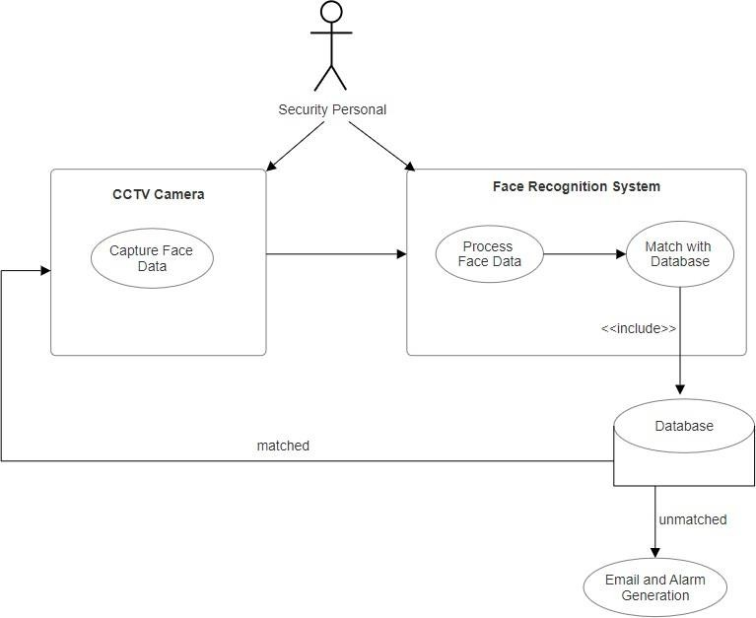

1. Face Data:

This Capture use case involves capturing facial data when a person enters the surveillance area. The camera is the primary actor responsible for capturing images or frames of the person's face. The person is a passive actor, being captured by the camera.

Steps:

* + The camera detects a person entering its field of view.
  + It captures images or frames of the person's face.
  + The captured face data is sent to the processing system for further analysis.

1. Process Face Data:

This use case involves the processing system's role in analyzing the captured face data for person detection. YOLOv5 (or a similar detection model) is responsible for processing the face data and identifying whether it is a person or not.

Steps:

* + The processing system receives the captured face data from the camera.
  + YOLOv5 processes the data to detect if a person is present in the image.

.

1. Match with Database:

In this use case, the processing system checks whether the detected person matches any records in the database of authorized individuals. It's a critical step for deciding whether the person is valid or not.

Steps:

* + If YOLOv5 detects a person, the processing system retrieves the facial features or templates of the detected person from the captured image.
  + The processing system searches the database for a matching record by comparing the detected facial features with the database entries.
  + If a match is found, the system marks the person as a valid individual, indicating that they are authorized.
    - If no match is found, the system treats the person as invalid and proceeds to generate an alarm and an email notification.

1. Database:

The database use case represents the interaction with the database where

authorized individuals' data, including their facial features, is stored. The database administrator is responsible for managing the database.

Steps:

* + The database administrator maintains and updates records of authorized individuals, including their names, identification information, and associated facial features.
  + During system setup, authorized individuals' data is added to the database through an administrative interface.
  + The database is regularly updated with new authorizations and deletions as necessary.

5.Email and Alarm Generation:

This use case involves generating email notifications and triggering alarms when an unauthorized person is detected.

Steps:

* If a person is detected but not matched with the database (i.e., an unauthorized individual), the processing system initiates alarm generation.
* An alarm, such as a siren or visual alert, is triggered on the premises to deter unauthorized access.
* Simultaneously, the notification system generates an email alert to notify security personnel or administrators.
* The email alert contains information about the unauthorized entry, such as the location and timestamp.

2) ACTIVITY DIAGRAM:

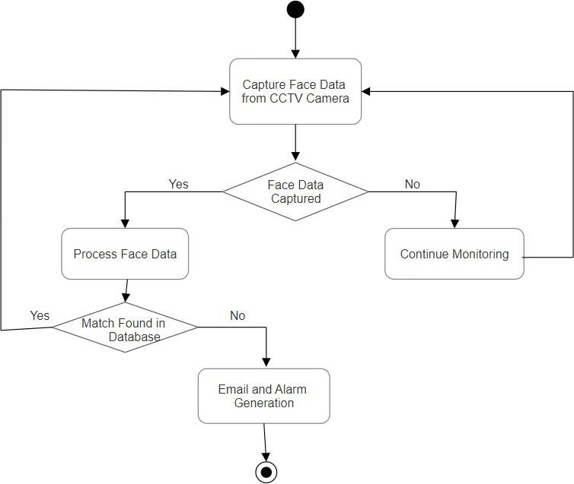

An Activity Diagram is a visual representation of a workflow that illustrates the sequence of activities and decisions within a system or process. In the context of capturing and processing face data with conditional branches, here's an explanation of the key elements and steps involved:

1. Capture Face Data from CC Camera:
   * This is the starting point of the diagram, representing the initiation of the process. It signifies the camera capturing the face data of an individual entering its field of view.
2. Decision: Face Data Captured? (Yes/No):
   * A decision point follows the face data capture activity. It checks whether the camera has successfully captured the face data.
   * If the answer is "Yes," the process proceeds to the "Process Face Data" activity. If it's "No," the process continues with "Continue Monitoring."
3. Process Face Data:
   * When face data is successfully captured, the system processes this data for analysis. This includes preprocessing and extracting relevant facial features.
4. Decision: Match Found in Database? (Yes/No):
   * After processing the face data, a decision point determines if a match with the database is found.
   * If a match is "No," it branches to the "Email and Alarm Generation" actions to indicate a recognized person.
5. Email and Alarm Generation (Match Not Found):
   * If a match is not found in the database, this activity involves generating an email notification with the recognized person's identity. Simultaneously, the alarm may be triggered to ensure security measures are taken.

## Module Description

1. Capture Module:
   * Description: The Capture Module interfaces with CCTV cameras, employing computer vision techniques to capture real-time video feeds. It extracts frames containing individuals entering the monitored area, providing a continuous stream of images for further processing.
   * Functionality: Utilizes camera APIs to capture video frames, employing motion detection or continuous capture to ensure relevant facial data is obtained.
2. Preprocessing Module:
   * Description: Upon receiving captured face data, the Preprocessing Module standardizes the format for efficient analysis. It may normalize, resize, or enhance image quality to improve recognition accuracy.
   * Functionality: Applies image processing techniques, such as histogram equalization or noise reduction, ensuring uniformity in the quality of captured face data.
3. Feature Extraction Module:
   * Description: This module analysis the preprocessing data, extracting distinctive facial features or templates. It employs algorithms to identify key points, landmarks, or numerical representations characterizing an individual's facial structure.
   * Functionality: Utilizes techniques like Eigen faces, local binary patterns, or deep learning-based feature extraction to represent facial characteristics.
4. Database Module:
   * Description: The Database Module stores and manages authorized individuals' data, including their facial features or templates. It provides a structured repository for efficient retrieval and comparison during real-time processing.
   * Functionality: Implements a relational database system, indexing facial features for quick retrieval, and supporting operations for updating, adding, or deleting authorized individuals.
5. Recognition Module (YOLOv5):
   * Description: The Recognition Module employs models like YOLOv5 for person detection. It determines if a detected face corresponds to a person in the monitored area, using deep learning techniques for real-time object detection.
   * Functionality: Integrates YOLOv5 or similar models, applying object detection algorithms to identify and localize persons within the captured video frames.
6. Decision-Making Module:
   * Description: The Decision-Making Module evaluates recognition results and database matching outcomes to make decisions on the identity and authorization of detected individuals.
   * Functionality: Implements decision logic based on predefined thresholds or rules, determining whether a detected person is authorized and triggering subsequent actions accordingly.
7. Notification Module (Email and Alarm):
   * Description: The Notification Module handles the generation of alerts and notifications based on recognition outcomes. It sends email notifications containing information about recognized persons and triggers alarms in case of unauthorized access.
   * Functionality: Integrates email APIs for sending notifications and interfaces with alarm systems to activate audible and visual alarms for immediate response.

## Why YOLOv5 Model ?

Utilizing YOLOv5 for a surveillance and facial recognition project offers numerous advantages, making it a compelling choice for real-time object detection:

1. Real-Time Processing: YOLOv5 excels in real-time processing, enabling swift and efficient detection of persons entering the monitored area. Its ability to process video feeds in near realtime is crucial for dynamic surveillance scenarios.
2. Object Detection Accuracy: YOLOv5's architecture allows it to detect and locate multiple objects in a single pass. This not only enhances the efficiency of person detection but also ensures high accuracy, reducing the likelihood of false positives or missed detections.
3. Versatility: YOLOv5 is versatile, accommodating various camera angles, lighting conditions, and facial expressions. Its adaptability makes it suitable for diverse surveillance environments, contributing to the system's robustness in different settings.
4. Dynamic Scenarios: YOLOv5 is well-suited for dynamic scenarios where individuals may be in motion. Its ability to handle continuous movement within a video feed makes it ideal for tracking and identifying persons entering or exiting a monitored area.
5. Feature Extraction for Facial Recognition: The deep learning capabilities of YOLOv5 facilitate robust feature extraction, a critical component for accurate facial recognition. Extracted features play a key role in determining the identity of individuals, contributing to the overall effectiveness of the system.
6. Open-Source Nature: YOLOv5 is open-source, providing developers with access to the model's architecture and codebase. This openness allows for easy integration into the project, enabling customization and fine-tuning based on specific project requirements.
7. Ease of Integration: YOLOv5's modular design and straightforward integration protocols make it accessible for developers. Its compatibility with popular deep learning frameworks simplifies the integration process into existing systems.
8. Resource Efficiency: YOLOv5 is designed to run efficiently on resource-constrained devices. This ensures that the model can be deployed on a variety of hardware setups, contributing to the scalability and accessibility of the surveillance system.

## Code Implementation

**

## 5.RESULT:

The detected image is checked with our database, if the image matched with any image in the database then it continues the process again otherwise this images that are stored is sent to designated recipients. Hence these images are required to send to the designated recipients.

We if observe that Match Found : Image.jpg it means as the person is already in the database when the camera captures that person then it will generate as Match Found otherwise it will sent mail.

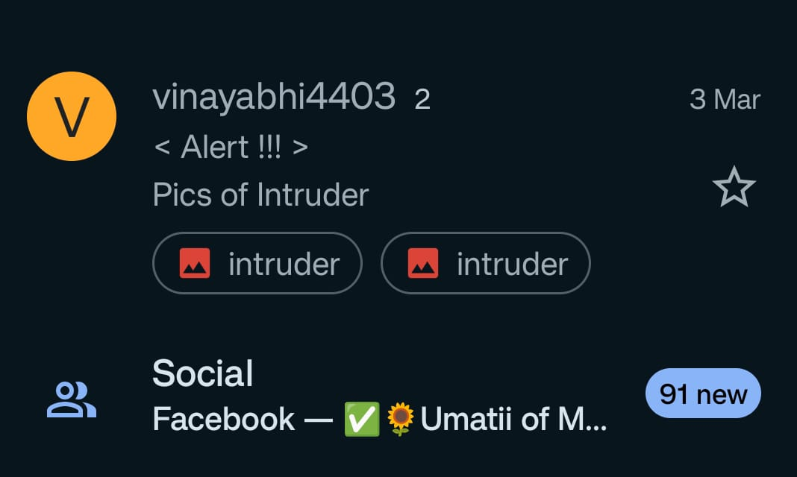

**6.CONCLUSION**

Intruder detection through video surveillance, powered by the YOLOv5 model and complemented by alarm generation and email notifications, signifies a revolutionary advancement in modern security technology. This comprehensive approach not only swiftly identifies intruders in real-time but also facilitates immediate responses, establishing it as a cornerstone for robust security systems across diverse environments.

The utilization of the YOLOv5 model brings unparalleled accuracy and efficiency to intruder detection. Its rapid processing of video frames minimizes false alarms, allowing security personnel to concentrate on genuine threats. This integration highlights the pivotal role of cutting-edge machine learning in enhancing security, enabling proactive responses to potential breaches.

The activation of alarms upon detecting an intruder adds a layer of effectiveness to the system. Immediate alarm response not only alerts individuals nearby but acts as a powerful deterrent, discouraging intruders and preventing potential losses. This capability in stills confidence in users, whether homeowners, business owners, or public space administrators, providing essential peace of mind in today's securityconscious world.

Real-time functionality enhances the system's effectiveness, with swift detection, assessment, and response capabilities. The instantaneous dissemination of information through email notifications ensures timely alerts to relevant individuals, enabling immediate action. This rapid communication is vital in preventing crimes, minimizing damages, and apprehending intruders promptly.

Furthermore, the integrated systems optimize resources by automating detection processes and providing intelligent alerts. This allows human resources to focus strategically on refining protocols and addressing emerging threats, contributing to overall operational efficiency. The widespread adoption of advanced intruder detection technologies fosters a safer society, creating a collective shield against criminal activities and promoting economic growth and a higher quality of life.

The inclusion of email notifications adds sophistication by promptly informing stakeholders about security breaches. These notifications, containing critical information such as images or video clips, enable remote assessment of situations, empowering users to make informed decisions swiftly.

In conclusion, the integration of video surveillance, the YOLOv5 model, alarm generation, and email notifications marks a paradigm shift in security technology. This holistic approach, with its unmatched accuracy, proactive response, and seamless communication, emerges as an indispensable tool for ensuring safety and security across various environments. As technology evolves.

### FUTURE ENHANCEMENT

1. Enhanced Object Recognition and Tracking Future developments in the YOLOv5 model could focus on improving object recognition and tracking capabilities. Enhanced algorithms could be designed to accurately identify and track intruders even in complex scenarios, such as crowded environments or adverse weather conditions. Additionally, advancements in machine learning techniques could enable the model to differentiate between various types of intruders, allowing for a more precise response.
2. Integration of 3D Sensing Technologies Integrating 3D sensing technologies, such as LiDAR (Light Detection and Ranging) or depth-sensing cameras, with the YOLOv5 model could provide an additional layer of information. By capturing the spatial dimensions of the detected objects, these 43 technologies could improve the accuracy of intruder detection and enhance the system's ability to recognize human behavior patterns, even in obscured or partially hidden situations.
3. Behavioral Analysis and Anomaly Detection: Future enhancements could involve implementing behavioral analysis and anomaly detection algorithms. By studying typical human behavior within a specific environment, the system could recognize deviations from these patterns, triggering alerts when unusual activities are detected. Behavioral analysis, combined with YOLOv5's object detection capabilities, could significantly reduce false alarms and enhance the system's overall reliability.
4. Real-time Threat Assessment and Risk Prediction Integrating artificial intelligence for real- time threat assessment and risk prediction could be a significant advancement. By analyzing historical data, environmental factors, and current security conditions, the system could predict potential security threats before they occur. This proactive approach would enable security personnel to take preventive measures, ensuring a higher level of security and safety.
5. Multi-Modal Sensor Fusion Future systems could explore the integration of multiple sensors, including video cameras, thermal imaging, and audio sensors, in addition to the YOLOv5 model. Multi-modal sensor fusion enhances the system's ability to corroborate information from different sources, increasing the accuracy of intruder detection. For instance, combining visual data from YOLOv5 with thermal imaging could improve detection in low-light or nighttime conditions.
6. Human-Machine Collaboration Future enhancements could focus on facilitating seamless collaboration between human operators and the intruder detection system. User interfaces could be designed to present relevant information intuitively, enabling security personnel to make quick and informed decisions. Integrating natural language processing and voice recognition